Stay connected:
Facebook – Windy Nook Methodist Church
www.windynookchapel.weebly.com

____________


WINDY NOOK METHODIST CHURCH
EASTER NEWSLETTER
I am the resurrection and the life.

EASTER NEWSLETTER

Sometimes we don’t like change I grew up enjoying a marathon chocolate bar now it’s a snickers. Ladies would enjoy looking after their skin with oil of ulay now its oil of olay why change? We are
undoubtedly in a time of change; things have changed in our lives over the past few days in a way we could never have imagined. I earlier queued to get in the supermarket at Jarrow, with the queue
snaking around the precinct as they let people in one by one, at a supermarket! The roads at 8am quieter than a lazy Sunday afternoon. We look at our television screens dismayed at the latest figures for coronavirus and wonder what is going on, when will this be over so we can get back to normal.

I was recently looking at some of the passages from Exodus that referred to the time when the Israelites were leaving Egypt. That was a difficult journey but undeniably God was always with them. God did make the journey any easier but when they were hungry the manna was sent form Heaven – Exodus 16 and when they were thirsty the water came from the rock – Exodus 17. We live in difficult times, but we do not face these times alone because we worship a loving and caring God who will be there for us. In our isolation in our loneliness God is there for us. In our fears and anxiety God is there for us. In Psalm 136 it says consistently that his steadfast love endures forever. Times change but God ‘s loving care for each of us does not waver but endures forever.

As we enter this time of Easter, we especially acknowledge the work of Jesus Christ whose incarnation proves the fact that God never leaves us alone and sends his only son. Jesus indeed cares for us and has empathy for whatever we face, remember that short verse “Jesus wept” at the death of his friend Lazarus. Remember also the last verse of Matthew’s gospel “I am with you always to the end of the age” We live in difficult times but we face them in the power of God ‘s love, love that endures forever and by the grace of God we will see, like the Israelites the promised land.

Keep safe and every Blessing
Rev Neil

THE CHURCH

So, what is the church? The hymns, the prayers, the books?
No, I mean, WHAT is the church, the coffee mornings, Slimming World, the dance class?

No, I mean, WHAT IS THE CHURCH? Well, it’s a small or big building where lots of people gather to worship God and sing Gods praise. It’s a place where hearts are open wide to the love of God.

We've been here for years you know, this building has been here for years. It has seen many generations through good and bad times, THIS is the church. We praise God that this building is still standing.
Yes, but the church building isn't open now. SO WHAT OR WHO IS THE CHURCH?

The people are the church, called into action as a response to the one who loved them first.

No books, no building, no problem. God calls you and me to be the church right where we are. Here and now, tomorrow, the next day, the next month, next year, the next millennia.

The church is love, the church is gift and care, the church is God in action, Christs hands and feet.

So let’s stop pretending what church is and stop talking about what the church is and let’s start being the church in whichever way we can. God calls us to be Gods church. So will you hear the call and be church in all the ways you can?

Rev Matt Sheard

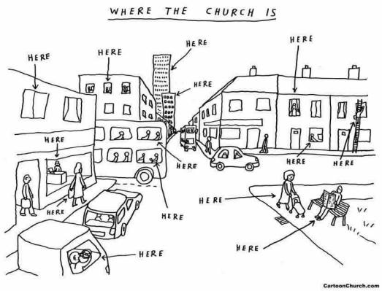

PRAYER
Loving God,
If we are ill, strengthen us.
If we are tired, fortify our spirits.
If we are anxious, help us to consider the lilies of the field and the birds of the air.
Help us not to stockpile treasures from supermarkets in the barns of our larders.
Don't let fear cause us to overlook the needs of others more vulnerable than ourselves.
Fix our eyes on your story and our hearts on your grace.
Help us always to hold fast to the good,
See the good in others,
And remember there is just one world, one hope,
One everlasting love, with baskets of bread for everyone.
In Jesus we make our prayer,
The one who suffered, died and was raised to new life,
In whom we trust these days and all days,
Amen.
The Revd Barbara Glasson, President of the Methodist Conference

CHURCH IN THE VIRTUAL WORLD

With the closure of churches, it has meant we can no longer attend church and gather for fellowship and worship as normal. It has brought much sadness, but also a huge challenge to the church. It is making churches around the world, re-think the way church happens. Much of this re-thinking has taken church online. Many churches are producing online material that people can engage with. This has included full services, bible studies, talks or prayers. In a way this is very exciting because it has the ability of reaching people who don’t attend church.

In our Circuit, the Bede Circuit, we have been using a video conferencing platform called Zoom to provide services. On Zoom, people ‘log in’ to a call and they can see and communicate with everyone else on the call. This has meant that people can gather online, have some fellowship and collectively join in worship. During our service, we had some prayers, bible readings and a sermon. Singing was not successful! The first service on the 22nd March, had some technical issues, but 56 people logged into the service. It was really lovely to be together and hear the word of God. That first week, the words and prayers were a big comfort. Even though it was different, and everyone was separate, a feeling of connection was there. It was a lovely surprise to feel so together and it was nice to be with others from the circuit. Over time, hopefully new relationships will develop.

These services are happening each week at present. Anyone is welcome to join in. To join, you need to use Zoom. You can use Zoom online at https://zoom.us/ or download the free app.
You need to create a free log in. To get into the worship ‘meeting’, you need relevant codes (a meeting number and password). These are shared each week online and via email. If you need any
help with this, please contact someone from church.

If Zoom isn’t for you, there is so much more going online. Many churches are broadcasting services on ‘Facebook live’ or doing recorded uploads on websites or YouTube. I have found it exciting
because I have been to more than one ‘church’ every Sunday. Usually, so many different service clash.

Locally, the ‘South West Tyneside Methodist Circuit’, have made a YouTube channel and have recorded services for people to view. Other Methodist Churches have done the same, including Methodist Central Hall in London. Online, on Singing the Faith plus, if you search ‘worship in the coronavirus pandemic’, there is a list of services to access. They have also uploaded some Bible studies and prayer that can be used at home.

Outside of the Methodist church, the BBC have been broadcasting a Sunday Morning service on BBC1 which is in addition to Songs of Praise. BBC Radio 4 have produced a number of services and
Christian programmes. You can find it online by searching ‘BBC Radio 4 Sunday Worship’. Other stations have material too.

So, in this time of change, be challenged to try church in a new way and be encouraged that God is there too; God is not fixed to the church building. Also remember, your church family are still here,
just spread out at home. Keep connected.

Sam
KEEPING IN TOUCH

This is such a difficult time for everyone, but in particular for those who fall into the category of vulnerable, as defined by the Government.

It has been easy to check up on people who use various forms of social media or WhatsApp, but more difficult for the older folk who don't use electronic methods of communicating. This has led to the realisation that we also don't have telephone numbers for some of the congregation.

So if you know of anyone who needs help with anything in these difficult times, please telephone Windy Nook Methodist Church on 0191 4386120.

The building may be closed, but the church is still open.

Sheila

WELLBEING IN A GLOBAL PANDEMIC

I hope you are all keeping well but I know that lots of people will be struggling in this difficult time for lots of different reasons. We all know that isolation and loneliness have a big impact on people’s mental wellbeing. It is completely normal to be having good days and bad days, to be struggling with feelings of worry more than you would ordinarily and struggling with the uncertainty of it all. However, this unique time we have all found ourselves in provides an opportunity to think about how we all live our lives so when the time comes when we can return to normal, take some time to pause to think about what things you would like to return to and what your normal will look like in the future. I’ve compiled a list of my top five ways to support your wellbeing in this difficult and unfamiliar time.

Find a Routine
In ordinary circumstances many of us have a weekly routine that we follow which may include shopping days, activity days, work or school etc. This new situation we’ve all found ourselves in has removed most of these things and the ones that remain no-longer look as they once did. Making a vague routine can be helpful when lots of things feel unpredictable, it doesn’t need to be a strict hour by hour schedule but planning to get up and dressed by a certain time helps to retain
normality, same with mealtimes and bedtimes. If it’s possible, try to do a new version of things you would usually do on certain days, if you usually go out with your Mam on Saturdays, why not video call instead. Try joining a streamed church service on Sundays. It may also be helpful to decide on a time to switch off your phone and do something to unwind on a night that doesn’t involve electricals, this will help you to get to sleep at a regular time.

Stay Connected
It is great that we live in such a technological world, it makes staying connected much easier, we have access to lots of different means of staying in touch with each other when we can’t leave the house. Make sure you check in on those who live alone more than you would usually, in this lockdown they may not be seeing anybody, particularly if they are classed as vulnerable. Equally if you are feeling lonely, give someone a call, we will all be struggling with this at different times. It is also important to take time to recognise when we may need to disconnect, if the news causes you anxiety read or watch it only once a day, particularly avoid accessing it close to your bedtime.
Be Mindful
Lots of people think that mindfulness sounds wishy-washy or is all about colouring in so hopefully I can clear it up! Being mindful is about being in the present moment, paying attention to the things
we don’t usually and experiencing things as they are – without judgement. Mindfulness isn’t about changing how we feel however it may help us cope with difficult feelings. Mindfulness is more about
the what is happening rather than the why it is happening. Our society is ordinarily quite obsessed with busy culture; people wear how busy they are as some sort of badge of honour when in fact it is not. Something as simple as sitting to drink your coffee rather than having a takeout whilst you do something else can instantly give you an opportunity to be more mindful. Mindfulness works best when you minimise distractions, turn off your phone/TV and use all your senses to notice what is around you. If it is drinking your coffee, pay attention to the smell and taste! Thoughts will enter your mind, that is normal, you can acknowledge that they are there. If you are getting caught up in your thoughts it is often helpful to bring your attention back to your breathing and focus on each breath. We have been given an opportunity to be more mindful in all that we do now that for the
majority us our pace of life has slowed down.

Remain Active
We are currently allowed to leave our homes for exercise once a day, it is good to get out if you can even if this is for a short walk. The NHS recommend we all do some sort of exercise/activity every
day, if you usually go to the gym you could use some online workouts to continue this at home. It’s always good to get some fresh air but more so we are now at the beginning of springtime. There are
signs of new life all around, signs of hope and a chance to continue to admire God’s wonderful creation.
Be Kind to Yourself and Others
You don’t need to be learning French or becoming a Pilates expert or to know how to teach the full curriculum to your child. You need to be kind to yourself as you navigate your way through this difficult time, a huge part of this is about trying not to compare your way of surviving to that of others. Now is the time to live day to day, start each day afresh, try not to dwell on a difficult yesterday or what might be to come tomorrow. Spread kindness wherever you can, we can all play a part, no matter how small and doing good for others boosts our mood.

Lots of organisations have released guidance for specific situations in this difficult time which you may find helpful:
- You can find advice about caring for someone with dementia at https://www.alzheimers.org.uk/
- Beat have information for people with eating disorders and those caring for them on their website which is https://www.beateatingdisorders.org.uk/
- Times of uncertainty and unpredictability can be very difficult for people with an autism spectrum disorder, The National Autistic Society have produced additional guidance at this time on their website: https://www.autism.org.uk/
- You can find easy read information about Coronavirus at https://www.mencap.org.uk/
- More general mental health advice can be found at https://www.mind.org.uk/ and for children and young people https://youngminds.org.uk/

RAINBOWS OF HOPE

As children begin home schooling, pupils from around the UK have joined together in a campaign of HOPE. Colourful pictures of rainbows have started appearing in windows during the coronavirus outbreak.
Pupils across the country are being encouraged to put up the paintings to spread hope during this troubled time.
The rainbow campaign is also a way of showing our support for the NHS and key workers. So… why not join in the campaign and help spread a little joy and hope in this very tough time.
Stay inside, stay safe and if you do go outside for some fresh air, how many rainbows can you see?

Gemma 

HOT MEALS

Hot meals delivery is available to all from the Elgin Community Kitchen.

- All meals cost £6.50 including dessert and delivery
- Vegan and Halal alternatives available
- Order every day - once a month (no contract or commitment)
- Order by 3pm Friday for following week
- Contact 0191 4400075 or 07912377228
- Unless stated all food is cooked fresh and delivered hot
- Staff are trained in Dementia awareness
Menu runs on a 2-week cycle:

Week 1 | Monday | Tuesday | Wednesday | Thursday | Friday
Main | Gammon  steak  mushroom  pineapple  and peas | Cumberland  sausage  served with  mash potato  seasonal veg  and onion  gravy | Chicken  Casserole | Cottage pie  served with  seasonal  veg | Salmon  fillet  served  with  boiled  potato  and  seasonal  veg
Dessert | Trifle | Apple  crumble  with  Custard | Rice  Pudding | Sponge  cake with  Custard | Cheese  cake

Week 2 | Monday |  | Tuesday | Wednesday |  | Thursday |  | Friday
Main | Brunch  Bacon  sausage  fresh  tomato  baked  beans egg  mushroom  and hash  brown |  | Meat and  potato pie  served with  boiled/ mash  potato and  seasonal veg | Roast  Chicken  dinner with  veg and  stuffing |  | Mince and  dumplings  served  with mash  potato  seasonal  veg and  rich gravy |  | Yellow  smoked fish  with mash  or new  potatoes  and a  vegetable  medley
Dessert | Trifle |  | Apple  crumble  with  Custard | Rice  Pudding |  | Sponge  cake with  Custard |  | Cheese  cake
Paninis |  | Sandwiches |  |  | Homemade Soups |  | Jacket Potato
Tuna Melt |  | Tuna Mayonnaise |  |  | Roasted Pepper |  | Tuna Mayonnaise
Mozzarella and  Red Onion |  | Cheese  Ploughman’s |  |  | Tomato and Basil |  | Cheese
Ham and Cheese |  | Deli Style |  |  | Ham Leek and Potato |  | Beans

CRISP PACKETS

Thank you to everyone who has been recycling crisp packets with us. This year, Sam has been able to box up and post away 17kg of crisp packets! Crisp packets are very light, so you can imagine that is a lot. These packets were sent to a company called Terracycle (www.terracycle.com), who recycle lot of different things that don’t go into general household recycle. Teracycle turn crisp packets into useful garden products such as watering can, picnic benches and flower pots. It is great to think that something useful is coming from
something that would have otherwise ended up in landfill.

Another bonus to this recycling, is that it has been earning much needed funds for Girls’ Brigade England &amp; Wales. Through the support of all the Girls’ Brigade groups in the country, they have raised over £1,000.

From now, Girls’ Brigade England &amp; Wales have decided to stop recycling crisps. Terracycle has made the process a little more difficult to manage. So, with this, Sam will not be able to post off large amounts of packets. But we can still collect packets and recycle them, by using local drop off point. On Low Fell, the ‘Open House &amp; The Spare Room’ shop, has a collection point and Sam is connected with a group in Whickham who run a number of recycling programmes.
If you do want to continue collecting crisps, we have to be mindful of the Coronavirus. At present, the current situation has meant that many local collectors have suspended their work and storing up lots of waste at home might not be the safest idea. Perhaps, once our lives go back to normal, you can start collecting. You might even want to look on the Terracycle and collect other things too!

Thanks again and let’s remember that we all have a part to play in looking after God’s wonderful creation.

Genesis 2: 15 ‘The LORD God took the man and put him in the garden of Eden to work it and keep it’.

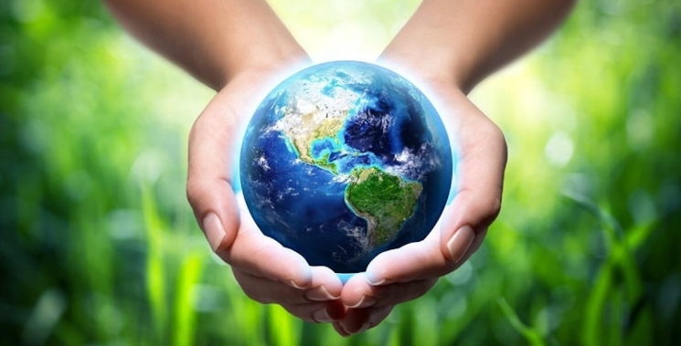

BAND NEWS

To supporters and friends of 1st Windy Nook Brigades and Methodist Youth Band. The decision has been taken for 1st Windy Nook Brigades Methodist Youth Band to take a hiatus. Things have become increasingly difficult lately with family, study and work commitments for myself and all leaders involved, making weekly practices difficult to attend and give 100% of ourselves to. We have also had a decline in regular members, which makes things more difficult to have productive rehearsal time.

We value each and every band member and leader and we thank you so much for sticking with us and doing your very best. We will reassess things in due course, hopefully returning with some fresh new ideas and some keen new (and returning) band members.

Thank you again to Windy Nook Methodist church and 1st Windy Nook Girls and Boys Brigades for the support over the years.
Please keep band in your prayers, as we ask God how to move forward in the future to do things justice and achieve our goals.

God bless,
Charlotte and the team x

COFFEE MORNING

Even before the official lockdown, we made the decision to postpone our coffee morning. We never meet in July and August, so all being well, we will be back in September.

In the meantime, here is the recipe for the banana cake that I make.
https://thehappyfoodie.co.uk/recipes/banana-loaf

Ingredients:
100g (4oz) butter, softened
175g (6oz) caster sugar
2 eggs
2 ripe bananas, mashed
225g (8oz) self-raising flour
1 tsp baking powder
2 tbsp milk

Essential kit:
You will need a 900g (2lb) loaf tin, 17 x 9 x 9cm (6½ x 3½ x 3½in) base measurement.

Instructions:
Lightly grease the loaf tin and line it with non-stick baking parchment. Pre-heat the oven to 180°C/350°F/Gas Mark 4. Measure all the ingredients into a mixing bowl and beat for about 2 minutes, until well blended; an electric mixer is best for this but of course you can also beat by hand with a wooden spoon.
Spoon the mixture into the prepared tin and level the surface. Bake for about 1 hour, until well risen and golden brown. A fine skewer inserted in the centre of the cake should come out clean.
Leave the cake to cool in the tin for a few minutes, then loosen with a small palette knife and turn the cake out. Remove the lining paper and leave on a wire rack to cool completely. Slice thickly to serve.
Enjoy and hopefully see you in September.
Sheila
LAST SUPPER

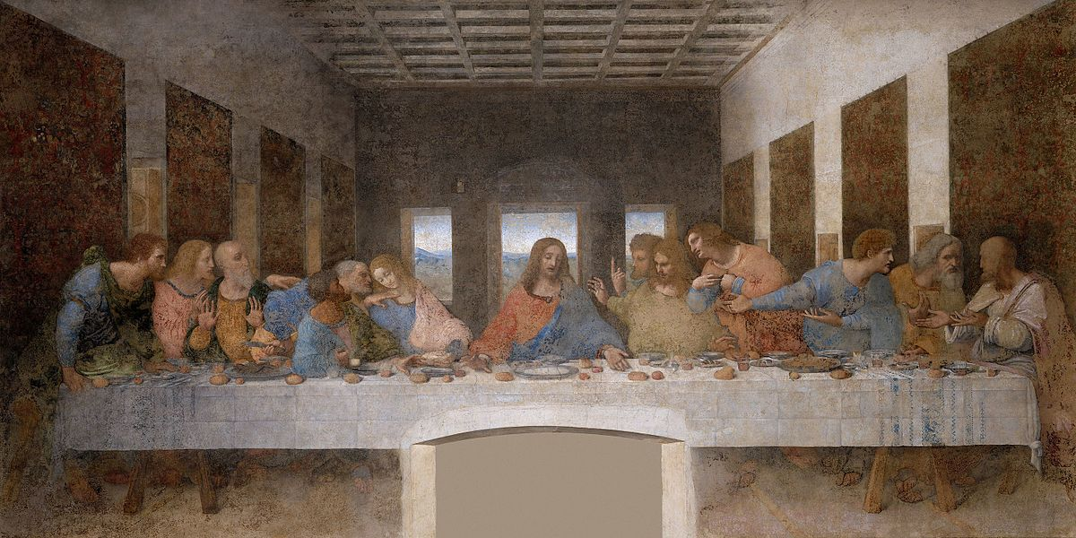

The story behind the painting of the Last Supper is extremely interesting and instructive.

Two incidents connected with this painting afford a most convincing lesson on the effects of thought in the life of a boy or girl, or of a man or woman.

The Last Supper was painted by Leonardo Da Vinci, a noted Italian artist. The time engaged for its completion was seven years. The figures representing the twelve apostles and Christ himself were painted from living persons. The live model for the painting of the figure of Jesus was chosen first. When it was decided that Da Vinci would paint this great picture, hundreds and hundreds of young men were carefully viewed in an endeavour to find a face and personality completely devoid of dissipation caused by sin.

Finally, after weeks of laborious searching, a young man, nineteen years of age, was selected as the model for the portrayal of Christ. For six months Da Vinci worked on the production of this leading character of the painting.

During the next six years Da Vinci continued his labours on his sublime work of art. One by one, fitting persons were chosen to represent each of the eleven apostles, space being left for the painting figure representing Judas Iscariot as the final task of this masterpiece. This was the apostle, you remember, who betrayed his Lord for thirty pieces of silver.

For weeks Da Vinci searched for a man with a hard callous face, with a countenance marked by scars of avarice and deceit, who would betray his best friend. After many discouraging experiences in searching for the type of person required to represent Judas, word came to Da Vinci that a man whose appearance fully met the requirements had been found. He was in a dungeon in Rome, sentenced to die for a life of crime and murder. Da Vinci made the trip to Rome at once, and this man was brought out from his imprisonment in the dungeon and led out into the light of the sun. There Da Vinci saw before him a dark, swarthy man, his long shaggy and unkempt hair sprawled over his face. A face which portrayed a character of viciousness and complete ruin. At last the painter had found the person he wanted to represent the character of Judas in his painting.

By special permission from the king, this prisoner was carried to Milan where the fresco was being painted. For six months the prisoner sat before Da Vinci, at appointed hours each day, as the gifted artist diligently continued his task of transmitting to his painting this base character in the picture representing the traitor and betrayer of the Saviour.
As he finished his last stroke, he turned to the guards and said, ‘I have finished, you may take the prisoner away’. He suddenly broke loose from their control and rushed up to Da Vinci, crying as he did so. ‘Oh, Da Vinci, look at me! Do you not know who I am?’ Da Vinci, with the trained eyes of a great character student, carefully scrutinised the man upon whose face he had constantly gazed for six months and replied; ‘No, I have never seen you in my life until you were brought before me out of the dungeon in Rome’. Then lifting his eyes towards heaven, the prisoner said, ‘O God, have I fallen so low?’

Then, turning his face to the painter, he said, ‘Leonardo Da Vinci, look at me again, for I am the same man you painted just seven years ago as the figure of Christ!’

This is the true story of the painting of the Last Supper that teaches so strongly the lesson of the effects of right and wrong thinking of an individual. He was a young man whose character was so pure and unspoiled by the sins of the world that he represented a countenance and innocence and beauty fit to be used for the painting of a representation of Christ. But during the seven years, following a life of sin and crime, he was changed into a perfect picture of the most notorious character ever known in the history of the world.

Compiled by J John & Mark Stibbe

QUIZ
1. How many boxes of chocolates did Queen Victoria send to Boer War soldiers on January 1, 1900? a) None b) 100 c) 1,000 d) 100,000
2. How many times round Britain would all the chocolate buttons sold in a year in the UK go? a) Once b) Three times c) 10 times d) 20 times
3. Which of the following was founded from a bequest to the nation from the man who invented milk chocolate? a) The Tate Gallery b) The British Museum c) The National Portrait Gallery d) The Wallace Collection
4. Whose last meal was four scoops of ice cream and six chocolate chip cookies. a) Elvis Presley b) Buddy Holly c) Michael Jackson d) Louis Armstrong
5. Bugs Bunny was the first cartoon character in the US to… what? a) Have a statue of him erected b) Appear in a painting in the New York Museum of Modern Art c) Be banned by the Vatican d) Appear on a postage stamp
6. What is the record for most yolks ever found in a chicken's egg? a) Four b) Six c) Nine d) 12
7. How many eggs a year do European hens lay? a) 850million b) 8.5billion c) 85billion d) 850billion
8. Which bird laid the largest known egg? a) The Great Auk b) The Giant Moa c) The Arabian Ostrich d) The Great Elephant Bird of Madagascar
9. In which ocean is Easter Island? a) Pacific b) Atlantic c) Indian d) Arctic
10. Which is the only Shakespeare play that mentions Easter? a) King Lear b) All's Well That Ends Well c) The Merry Wives of Windsor d) Romeo and Juliet

Answer can be found on the back page.

PRAYER

God of all hope we call on you today.
We pray for those who are living in fear:
Fear of illness, fear for loved ones, fear of other’s reactions to them.
May your Spirit give us a sense of calmness and peace.
We pray for your church in this time of uncertainty.
For those people who are worried about attending worship.
For those needing to make decisions in order to care for other
For those who will feel more isolated by not being able to attend.
Grant us your wisdom.
Holy God, we remember that you have promised that
Nothing will separate us from your love – demonstrated to us in Jesus Christ.
Help us turn our eyes, hearts and minds to you.
Amen

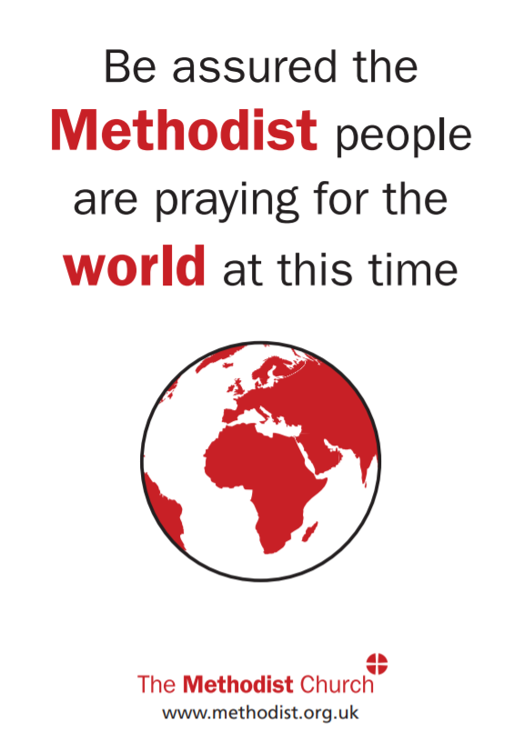
HOLY WEEK AND EASTER AT WINDY NOOK

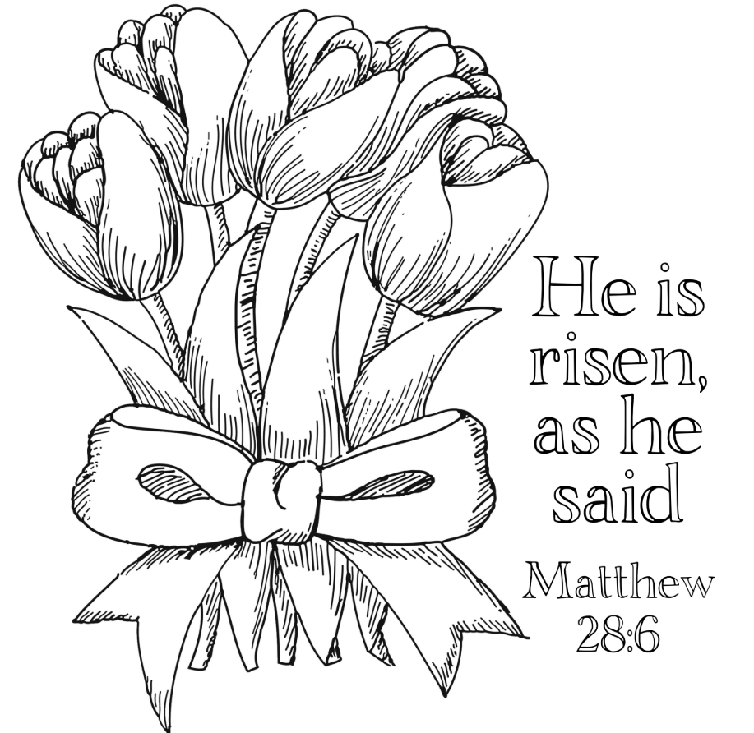
As you can imagine, all the events and services we had hoped to enjoy this year have had to be cancelled because of the coronavirus.

We will miss these special events very much, but we still remember the realities of Good Friday and Easter Sunday. Jesus gave his life for us and rose again to be with us always.

‘God loved the world so much that he gave his only son so that whoever believes in him might not perish but have everlasting life.’

Quiz Answers: 1) D, 2) D, 3) B, 4) A, 5) D, 6) C, 7) C, 8) D, 9) A, 10) D

