WINDY NOOK NEWSLETTER EASTER 2023

Easter Services (Holy Week)
Palm Sunday 10.30am led by Jane
6pm led by Paul

Monday Lent Group 7pm

Wednesday Shared meal at St. Albans 7pm

Good Friday 10.30am led by Paul

Easter Sunday 6am Sunrise Service with St. Albans – playing field Albion Street
10.30am led by Paul

Some egg-cellant jokes
Why did the Easter egg hide? Because he was a little chicken!
What’s the best way to send a letter to the Easter bunny? By hare mail!
Why shouldn’t you tell an Easter egg a joke? Because it might crack up!
What’s the difference between a crazy bunny and a counterfeit note?
One is bad money and the other is a mad bunny!
How do Easter bunnies stay healthy? Eggs-ercise!
Why are people always tired in April? Because they’ve just finished a March!
What do you call ten Easter bunnies marching backwards? A receding hareline!
How many Easter eggs can you put into an empty Easter basket?
One- after that the basket won’t be empty!
And finally…..
Why do Easter eggs go to school/ To get an egg-ucation!
The Easter Bunny.
If you think the Easter Bunny is a modern invention then think again!
We’ve got the ancient Anglo-Saxons to thank (if that’s the right word) for a floppy-eared animal getting the star treatment.
They worshipped the pagan goddess, Eastre who was symbolised by guess what? Yep, you got it ….a rabbit (well actually it started out as a hare but because there were more rabbits around things sort of got changed along the way)
So when and where did the cute little bunny get linked in with the Easter that we know and love?
Almost certainly in Germany sometime in the 1500s. The good old Germans can also take the credit for making the world’s first edible Easter bunnies during the early 1800’s They hadn’t quite got around to doing chocolate ones so it was scrummy pastry and sugar bunnies instead,
(well, sort of scrummy if you prefer pastry to chocolate)
During the 1700s the Easter bunny was taken to America by settlers from Germany, who took their Easter traditions with them to Pennsylvania. One of these , was a figure called Oschter Haws, who was a favourite with youngsters- second only to Santa Claus or Kris Kringle. The children believed that if they were good, the Oschter Haws would lay a nest of brightly coloured eggs!
Of course there were two problems with this !
- The Easter Bunny was supposed to be male and 2 we all Know that rabbits can’t lay eggs!

However this didn’t really deter them.
The children would build a nest in a secluded place in the home, garden or shed. Boys would use their caps and girls their bonnets to make the nests, and that’s where the use of elaborate Easter baskets from.
Quiz
- How many Easter Eggs are sold in the UK every year?

- Which country started the tradition of the Easter Bunny?

- How many marzipan balls are traditionally on a simnel cake and what do they represent?

- What is the tradition behind a Hot Cross Bun?

- What is the Sunday before Easter called?

- What is the official flower of Easter?

- Where is Easter Island located?

- Easter has to fall between which two dates?

- In the Bible who betrayed Jesus just before his crucifixion?

- What dance traditionally takes place at Easter?

The Easter Egg (eggs-plained.)
Using an egg to celebrate something (like we do at Easter) is not a new phenomenon. If you travel back in time you’ll discover that the egg was a symbol of rebirth in most cultures.
Eggs were often wrapped in gold leaf or, if you were poor, coloured brightly by boiling them with the leaves and petals of certain flowers.
The Egyptians buried eggs in their tombs.
The Greeks placed eggs on the top of graves…
Eggs were also given as gifts by the ancient Greeks, Persians, and Chinese at their spring festivals.
All in all the humble egg appears to have been quite well thought of through the ages.
In some parts of Germany (during the early 1880s) Easter eggs were substituted for birth certificates! . First off, the egg was coloured with dye. Then a design (which included the baby’s name and birth date) was etched into the shell with a needle or sharp tool. Amazingly these rather unusual birth certificates were acceptable legal evidence of identity and age! How odd!
Decorating and colouring eggs for Easter was also the custom in England during the middle ages. . The household accounts of Edward 1 (for the year 1290) recorded an outlay of eighteen pence for four hundred and fifty eggs which were to be covered with gold and coloured as Easter presents!
How much do you pay for an Easter egg?
Faberge Eggs were hand-crafted in the 1880s by the great goldsmith Peter Carl Faberge and were commissioned by Czar Alexander 111 of Russia as gifts for his wife, Czarina Maria Feodorovna.
The first Faberge egg measured two and a half inches long and had a deceptively simple exterior. However, inside the white enamel shell was a golden yolk which, when opened, revealed a gold hen with ruby eyes. The hen could be opened by lifting the beak to reveal a tiny diamond replica of the imperial crown. Which is surely better than a bag of buttons!!
Faberge eggs have regularly sold for millions of dollars- the highest 9.6 million dollars.

EASTER AROUND THE WORLD
Easter is a Christian holiday with celebrations honouring Christ’s resurrection from the dead. Though the same holiday is celebrated around the globe, the ceremonies and customs vary from country to country. Here are a look at some of the unique ways Easter is celebrated around the world.
In FRANCE the Easter bunny is replaced by church bells. According to tradition, when the church bells stop ringing from Good Friday to Easter Sunday, the bells sprout wings enabling them to fly throughout the cities delivering sweet treats to children.
The SOUTH OF FRANCE has its own tradition on Easter Monday with a giant omelet served in the town’s square. The tradition dates back to a time when Napoleon and his army traveled through the area, stopping at the village of Haux, where they were served omelets. Napoleon was so pleased with the breakfast dish, he ordered the villagers to collect all their eggs to make a giant omelet big enough to feed an army - literally.
Cold temperatures don’t deter the people of POLAND in their quest to maintain their Easter tradition of drenching one another with buckets full of water. The tradition dates back over 1,500 years. Originally the ceremony was a representation of baptismal water but, today, the tradition is more recreational.
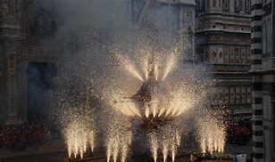
A 350-year-old Easter ritual continues to this day in Florence, ITALY. The ‘Explosion of the Cart’ known as Scoppio del Carro, is meant to ensure an excellent harvest in the coming Spring. An ornamental cart full of fireworks is paraded around the streets by participants dressed in 15th-century costumes. The procession ends outside the Duomo (church) as the Archbishop of Florence ignites the fuse during Easter mass. When the lit fuse reaches the cart, a festive fireworks display is showcased for spectators to enjoy.

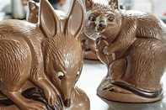
In AUSTRALIA the Easter tradition is rather recent in history. The tradition began in 1991, with a modern update to a tradition already in existence. Up until 1991, Easter treats were delivered by the Easter Bunny. In 1991, a campaign was waged to replace the Easter bunny with the Easter Bilby, as rabbits are considered pests that destroy the crops.

EINSTEIN’S RIDDLE

The popular lore of the riddle traces it back to Einstein's teaching days. According to the story, the scientist gave the riddle to students to discourage them from picking him as their academic advisor, though this is likely just a legend. Another dubious element has been added to the riddle's story since it hit the internet: Allegedly only 2 percent of the world's population can solve it.

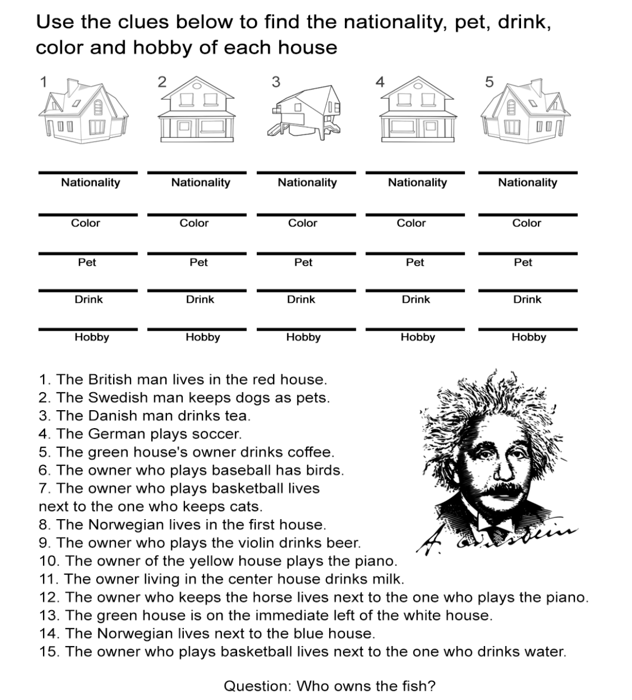

Can you solve the riddle ?

Text your answer to Kaz: 07505 822205

Thank you

A huge thank you to everyone who donated gifts for the Embells Christmas appeal. It was hugely appreciated and Emma wanted to pass on her heartfelt thanks for your generosity especially given the current economic climate.

Embells have a weekly community market and food pantry in Onebodyonelife (gym) in Fewster Square every Friday 11.30-2.30.

Quiz Answers
- 80 million
- Germany
- 11 – representing disciples excluding Judas
- Cross on which Jesus died
- Palm Sunday
- White Lilies
- South-East Pacific Ocean
- March 22 and April 25
- Judas
- Morris Dancing

